Installing the Toyota EPC application
You’re going to need at least 20 MB of free space for the program and catalog files. If you are installing to an NTFS-formatted drive (Windows NT, 2000, XP) you may get an error during the CD Setup phase that there is not enough drive space, even though there really is adequate space. This is due to the fact that the software is really old.
Another problem is that the program will refuse to install the catalog (data) files on NTFS drives that have more than about 5GB of free. You can work around this by creating a temporary folder and copying very large files into it until you have less than 5GB free. After installation, you can delete the folder.
Ken Blake offered a tip to install the catalogs onto a thumb drive (USB Drive) to work around the large disk issue. The only inconvenience is that you would need to plug it in when you ran the program, and also that you would need to make sure that other USB devices didn’t assume the drive letter that the thumb drive assumed when the program was installed.
- Insert Disk A1, navigate to the EPC folder:
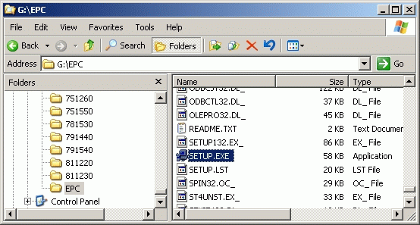
Launch Setup.exe.
- The Welcome screen will appear:
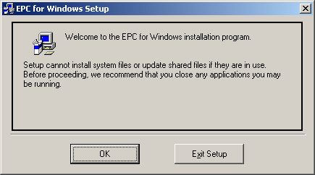
Click OK.
- Choose a drive to use:
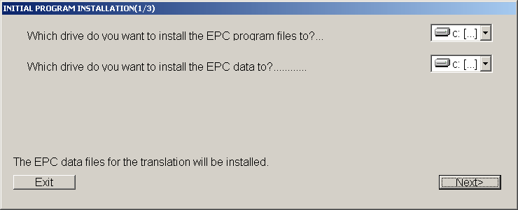
Click Next.
- You’re asked to identify the number and location of the CD-ROM drive you wish to use (where CD1 is located):
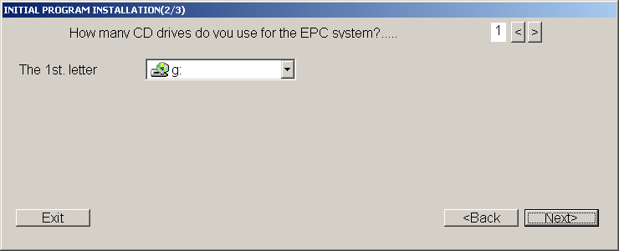
Pick the appropriate drive, then click Next.
- You’ll be prompted about Client/Server:
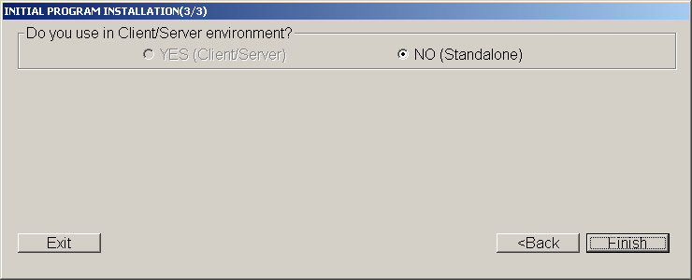
Since “YES” in unavailable, click Finish.
- A progress window will track the status of the file copy:
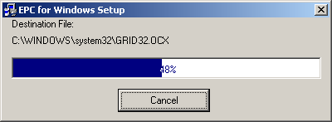
- When complete, a window will advise you that setup was successful:
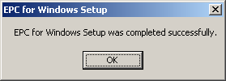
Click OK.
- The program shortcut is named EPC for Windows.
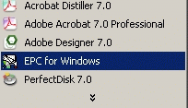
- The first time you launch it, you need to set up the catalog location. After launching, the Main Menu will appear:
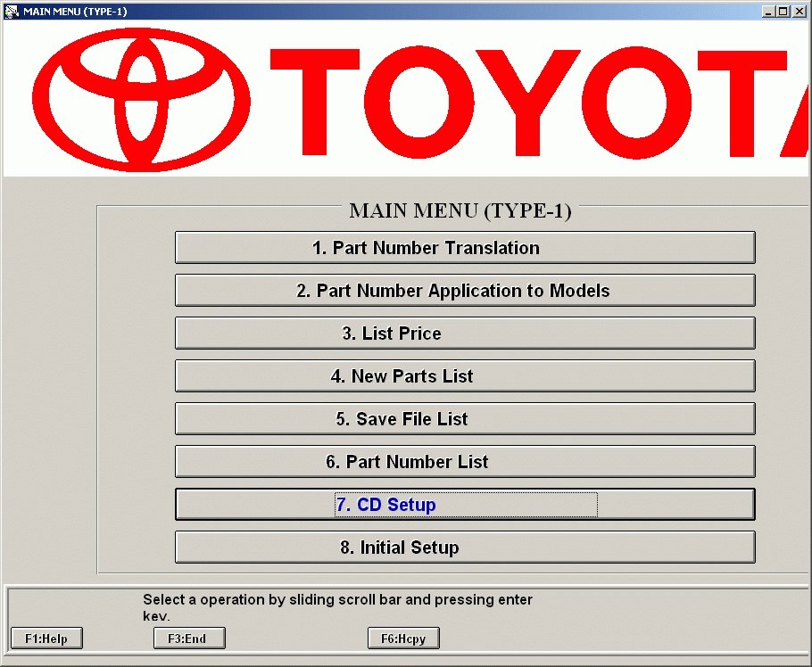
Click CD Setup.
- Next, you’ll be offered other setup options:
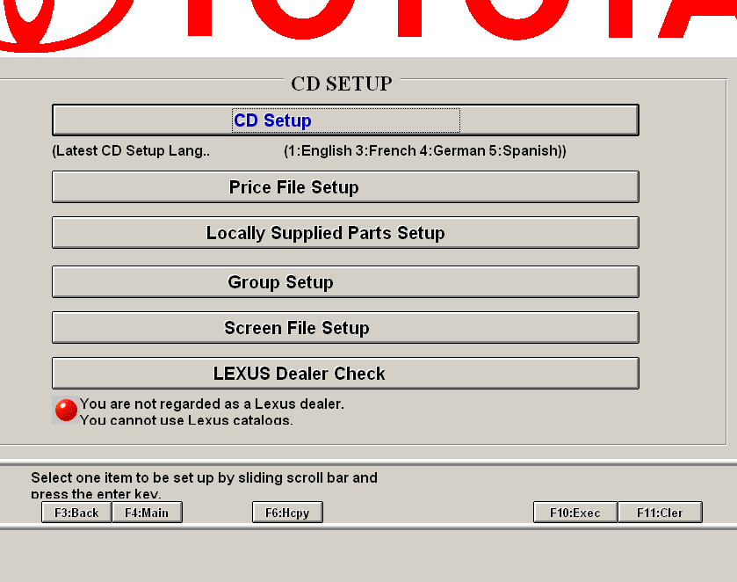
Click the first choice, CD Setup.
- The CD Setup screen will appear:
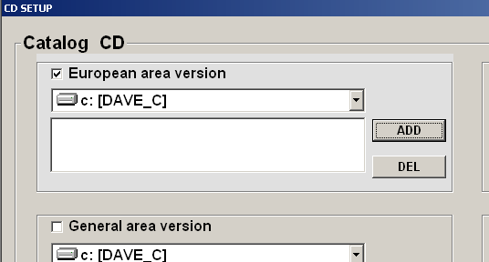
In the upper-left corner, check the box that reads “European version” (this is the Euro version, but includes the North American models, so it’s totally accurate). Select the hard drive where you wish to install the catalog files.
If you wish to use a thumb drive for the catalog files, specify the drive letter of the thumb drive here.
Click ADD.
- The Change Status window will appear:
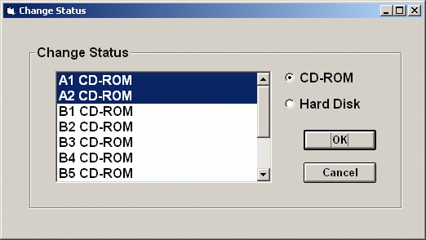
Select A1 CDROM and A2 CDROM, then Click OK.
(Hint: Hold down the shift key while you click to select multiple CD-ROMs.)
- Press the F10 key or click the F10 icon at the bottom of the screen. This will copy the catalog files to your hard drive. You’ll be prompted to insert the Eur A2 CD when the catalog for Eur A1 CD is finished. Click Retry.
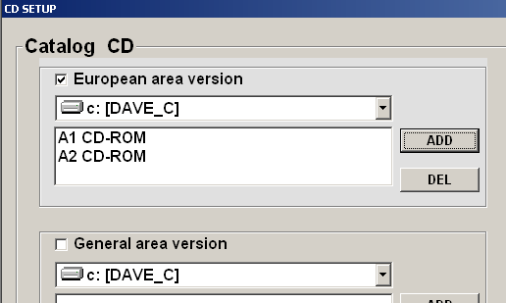
This is where you will run into problems on NTFS volumes with greater than 5GB of free space.
- Data will be copied from the CD to the hard drive. After a while, you’ll be prompted to insert CD A2:
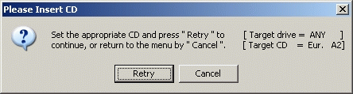
When the CD is in the drive, click Retry.
- When finished, you’ll be returned to the CD SETUP screen.
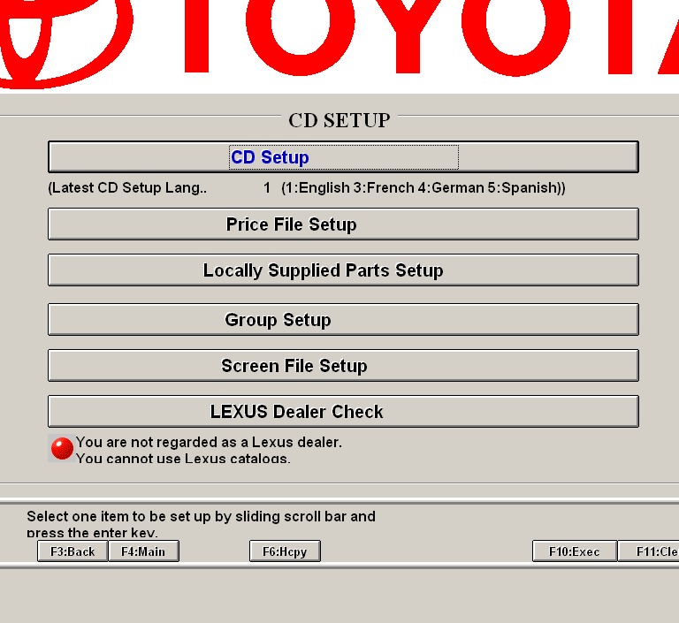
Click Back (or press F3).
- You’re back at the MAIN MENU: 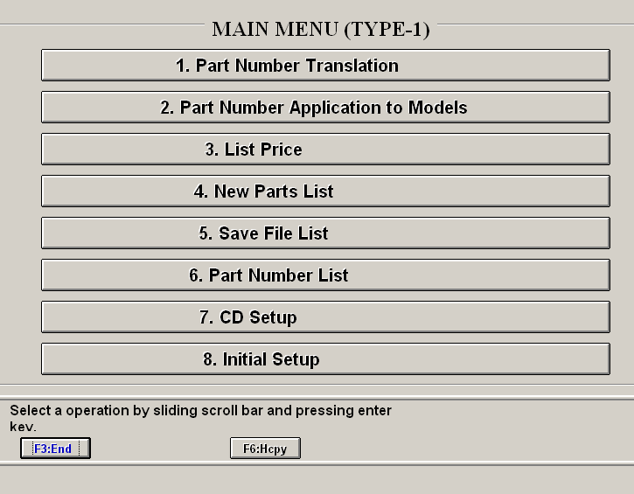
Click Finish (or press F3).
- Once you’ve run the setup, you’ll have several folders whose names begin with TMCxxxxxxx. These are the folders for the EPC application, so don’t delete them.
TMCEPCW1 = Program
TMCTMPW1 = Temp folder
TMCMSTW1 = Catalog Files
To use the application, insert A1 CD in the CD-ROM drive, then launch the program. Click Part Number Translation. The best way to look up parts is to input your vehicle’s VIN, then click the Save button (under Vehicle Identification) to save that VIN. When you open the program again, click the Open button (under Vehicle Identification) and the file you saved should appear in a file browser window. Select that file and it will open the file for your VIN automatically. With your VIN entered, you’ll get correct part number translations for most things.
The rest of the program is fairly straightforward; you’ll learn how to find things with practice.
Some tips:
When a parts diagram appears, click on it once with the left mouse button to enlarge it.
The search engine is pretty lame because the naming of parts seems pretty random. Probably a result of translation issues.
While it appears to be logically arranged, finding parts sometimes takes a lot of time because they don’t appear in the catalog where you think they should. Be patient.
Not every part is cataloged, but that’s just the way it is.
Printing with the F2 Prnt key/button will print only the graphic parts image, but it will NOT print a zoomed image – only the entire view. Using the F6 Hcpy button will print the surrounding text (like the parts list) AND it will print a zoomed image. However, if you have zoomed in to the image, the surrounding text will likely be chopped off. The F6 Hcpy is generally the more useful of the two.
There are other idiosyncrasies with the way this app works, but it’s the only one available. And it’s often the only view to the way some parts go together, especially when trying to navigate the myriad of hoses and connections. I thought my CVCC Honda motor had a lot of hoses (and it did), but the MR2 Turbo gives it a run for its money.

